*CHEM 342 – Lecture 2 08/01/2015*

Overheads: - Today’s Outline

- Old Ads

1) Questions from first class

2) Recap: The Best and the Worst

The best: glucose

Raymond “Sugar Ray” Lemieux”:

* 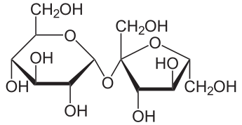From Lac La Biche, AB, born 1920
* 1953: first to synthesize sucrose (considered the Mt Everest of Organic Chemistry)
* 1954: started Department of Chemistry at UOttawa
* 1961: Returned to UAlberta
* Won every award except Nobel
* Died 2000

The worst: nicotine

* 1 cigarette = ~ 1 mg nicotine inhaled
* LD50 = 3 mg/kg in mice; 0.5-1 mg/kg in humans (disputed)
* Lethal dose ~ 30-60 mg in adult human (don’t spill liquid on skin!)
* Not an identified carginogen BUT *promotes* cancer.

Some interesting uses of well-known molecules

3) Recap: Mechanisms

3 Questions:

1. What is the strongest acid?
2. What is the strongest base?
3. Is there a good leaving group?

\*\*If you haven’t seen it (a reaction step) before it is probably wrong!

Problem from last class:



So far:



1. Acid/Base
2. LG leaves from tetrahedral intermediate “I know all these reactions” ☺
3. Nu­ adds to C=O
4. Acid/base

Explain three related reactions:









Another one:



Last one:

